**LABORATORY WEEK11 RAPORT**

**1)TTL TSL**

**->code**

**->graphs**

**DC analysis**

**TR analysis**

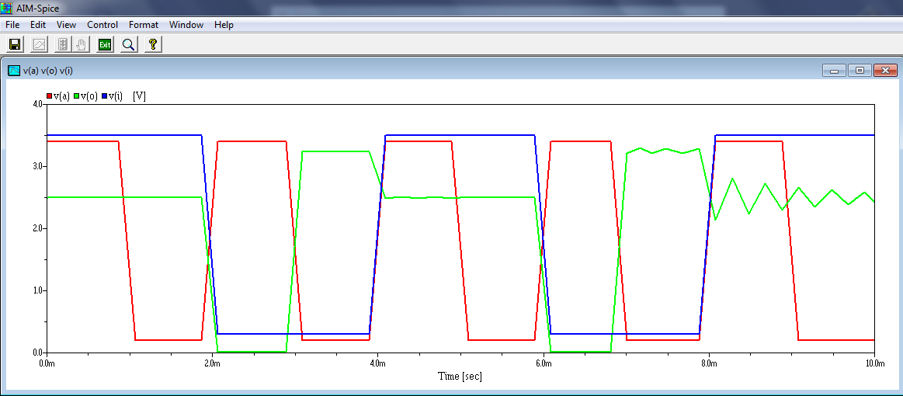

**CMOS TTL**

**->code**

**DC analysis**

**TR analysis**

